H.T No
Regulations:
A20

Sreenidhi Institute of Science and Technology
(An Autonomous Institution)
Code No:8A201 Date: 13-Sept-2021 (FN)

B.Tech I-Year II- Semester External Examination, Sept-2021 (Regular)
ELECTRICAL CIRCUITS AND NETWORKS-I (EEE)

Time: 3 Hours Max.Marks:70

Note: a) No additional answer sheets will be provided.
b) All sub-parts of a question must be answered at one place only, otherwise it will not be valued.
c) Missing data can be assumed suitably.

ANSWER ANY 5 OUT OF 8 QUESTIONS. EACH QUESTION CARRIES 14 MARKS.

Bloom's Cognitive Levels of Learning (BCLL)

Remember | L1 | Apply | L3 | Evaluate | L5
Understand | L2 | Analyze | L4 | Create | L6

 |  |  | BCLL | CO(s) | Marks
1. | a) | The voltage waveform shown in below figure is applied to a pure capacitor of 50 μF. Sketch i(t), p(t) and determine I_{max} and P_{max}.  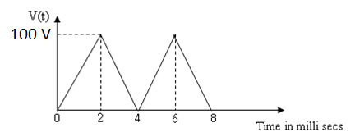 | L3 | CO1 | [7M]
 | b) | Determine the equations for delta-star transformation. | L2 | CO1 | [7M]
2. | a) | Define graph, tree, basic cut-set, tie-set matrices each with example. | L1 | CO2 | [7M]
 | b) | Draw oriented graph of the network and find tie-set matrix of the below network.  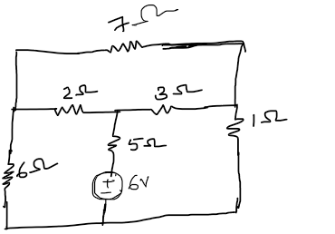 | L4 | CO2 | [7M]
3. | a) | Elaborate on Self-inductance and Mutual inductance. Derive a relation for coefficient of coupling. | L4 | CO3 | [7M]
 | b) | Evaluate equivalent inductance of the below circuit and derive corresponding relation.  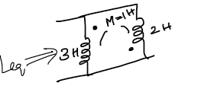 | L5 | CO3 | [7M]
4. | a) | Analyze the RL series circuit connected to a voltage source. Draw the phasor diagram and mention required relations. | L4 | CO4 | [7M]
 | b) | Find the equivalent impedance of the following circuit.  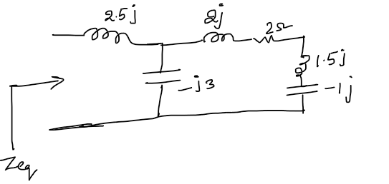 | L6 | CO4 | [7M]
5. | a) | Draw the locus diagram for RL circuit with Variable Resistance. | L5 | CO5 | [7M]
 | b) | Determine various specifications of a parallel resonance circuit and draw out important conclusions. | L4 | CO5 | [7M]
6. | a) | State and prove Compensation theorem with an example. | L3 | CO6 | [7M]
 | b) | Find the value of Z_{L} to be connected between the terminals AB of the circuit shown in below figure, for maximum power transfer. Find maximum power.  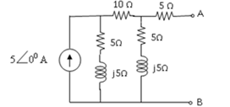 | L3 | CO6 | [7M]
7. | a) | Find current through and voltage across each and every element of below figure using mesh analysis.  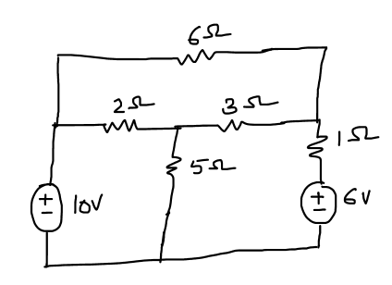 | L5 | CO1 | [5M]
 | b) | Differentiate between planar and Non-planar Networks each with an example. | L2 | CO2 | [5M]
 | c) | What is the importance of dot convention in magnetic circuits. | L3 | CO3 | [4M]
8. | a) | Define Real power, Reactive power, complex power and power factor. | L5 | CO4 | [5M]
 | b) | Draw the locus diagram of R-L-C series circuit when varying X_{L} and X_{C} with neat explanation. | L4 | CO5 | [5M]
 | c) | Explain Norton’s Theorem with an example. | L3 | CO6 | [4M]

-- 00 -- 00 –

